DHCP - Worksheet

- As you work through the project, complete the network documentation sheet. The current access passwords have been included. Change and document all passwords. Create different passwords for each device and function. For IP addresses, if device receives address from DHCP, type DHCP. If statically assigned, type the IP Address | Points Possible | Points Awarded
Device Interface IP Address CIDR Secret Password Telnet Password  Stud 1-4 NIC DHCP N/A N/A  Classroom Laptop NIC DHCP N/A N/A  ClassSwitch VLAN1 192.168.1.3 /24 cisco_csecret cisco_ctel  OfficeSwitch VLAN1 192.168.1.2 /24 cisco cisco  Network Laptop NIC DHCP /24 N/A N/A  MgtRouter Ge0/0 192.168.2.2 /24 cisco_mgt cisco_mgttel  Ge0/1 192.168.1.99 /24  DHCP Router Ge0/0 192.168.2.1 /24 cisco_drsecret cisco_drtel  Ge0/1 192.168.3.1 /24  Ge0/2 192.168.4.1 /24  Serial 0/0/0 198.3.24.3 /24  WebSwitch VLAN1 192.168.3.2 /24 cisco_wsecret cisco_wtel  WebServer NIC 192.168.3.3 /24 N/A N/A  AdminSwitch VLAN1 192.168.4.2 /24 cisco_secret cisco_tel  “C” Computers NIC DHCP /24 N/A N/A | 5

- Why is network communication blocked by the Management Router? Describe the problem and how you fixed it. | Points Possible | Points Awarded
Write comments here. | 3
Replace this shape with a snip of the tool you used to find the information to properly configure the ClassSwitch, OfficeSwitch, and Network laptop | 1

- Disable the ClassSwitch port that is connected to the “Rogue” Laptop. Secure the laptop until the Boss returns from his fishing trip. | Points Possible | Points Awarded
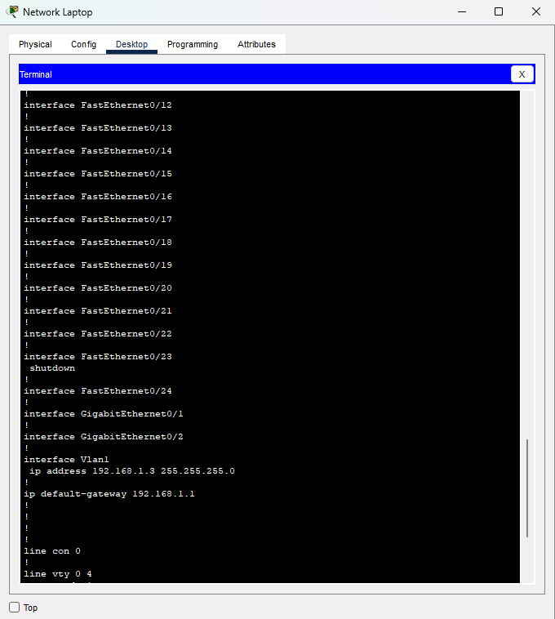 | 1

- Configure a DHCP Pool for the Classroom and Main Office network. Don’t forget to exclude addresses of statically configured devices (Network Laptop, ClassSwitch, OfficeSwitch, MgtRouter | Points Possible | Points Awarded
Replace this shape with a snip from the running configuration showing the created DHCP pool and excluded addresses | 2

- Access any of the Stud# computers. Show the DHCP address assignment. Open the web browser and attempt to access the “Internet” (192.168.5.2). | Points Possible | Points Awarded
Replace this shape with a snips from a Stud# computer showing the results of “ipconfig” and a snip of the webpage from the “Internet”. | 2

- Assuming the Stud# computers received DHCP assignments, what command(s) must have been configured on the gi0/1 interface of the MgtRouter? | Points Possible | Points Awarded
Command(s): | 1

- Create DNS “A” records for the ClassSwitch, OfficeSwitch, WebSwitch, WebServer, and AdminSwitch. | Points Possible | Points Awarded
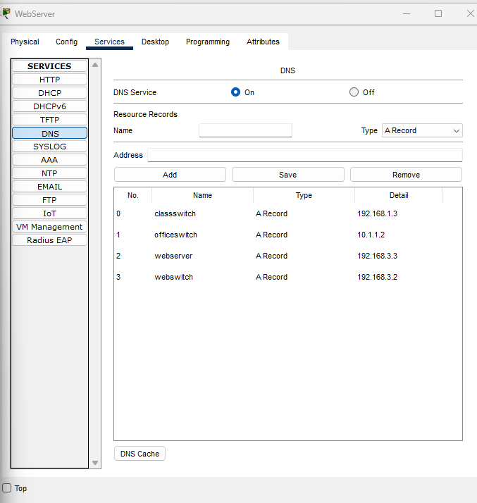 | 2

- From the Network Laptop, attempt to ping any of the resources assigned “A” records in DNS using the created name | Points Possible | Points Awarded
Replace this shape with a snip from the Network Laptop of a successful ping of a resource using the DNS name. | 1

- Configure the Admin Switch for telnet access. Take any other steps required to have a relatively secure switch (passwords, line configurations, console configurations) | Points Possible | Points Awarded
Replace this shape with a snip from the Network Laptop of a telnet session with the AdminSwitch. In the session, display the portion of the running configuration dealing with vty configurations. | 2

Total Possible Points | Total Points
20

